**Beginner Git Project-1**

**Step1:** Download the HTML Code Online

Changing the HTML, CSS and JavaScript Code according to my details.

**HTML:**

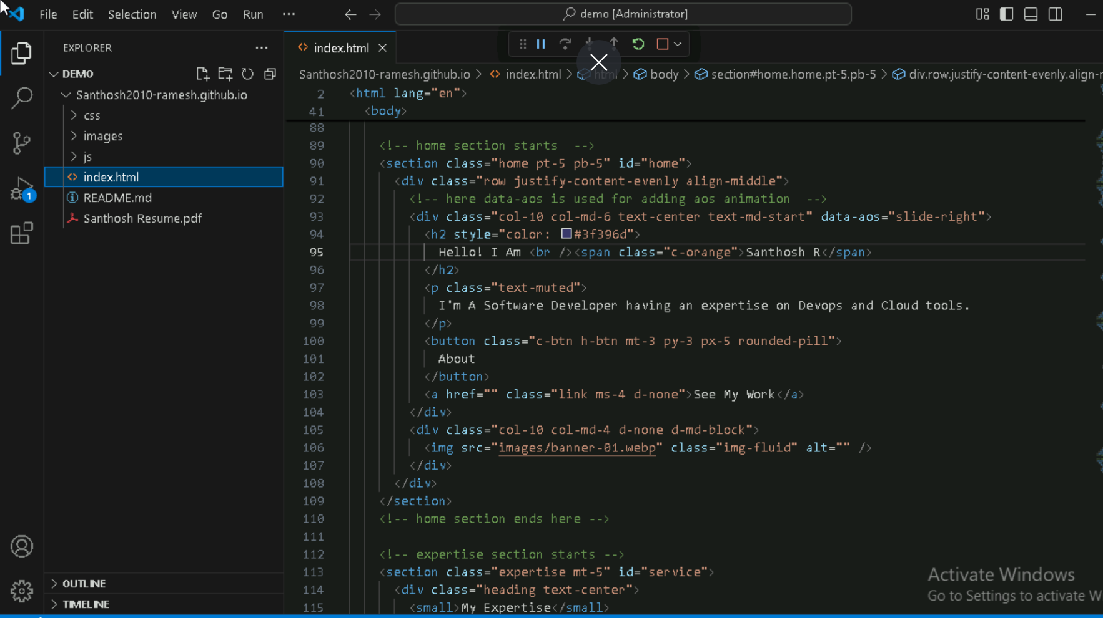

**CSS:**

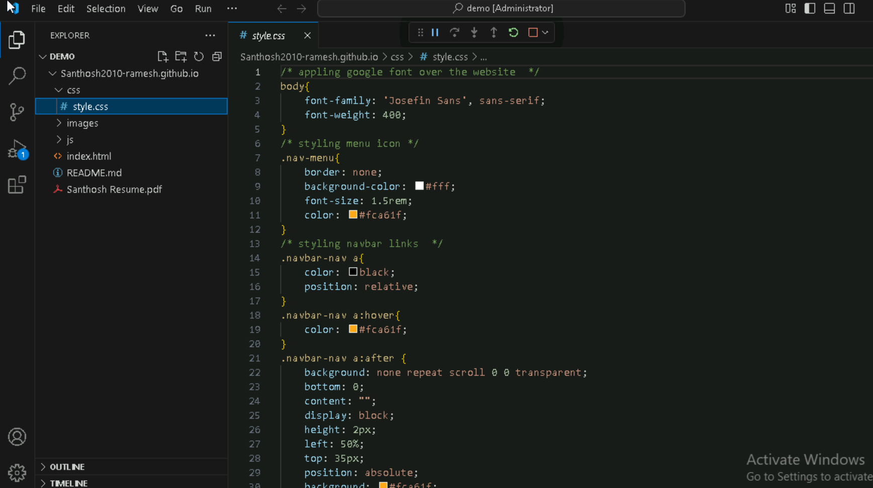

**JavaScript:**

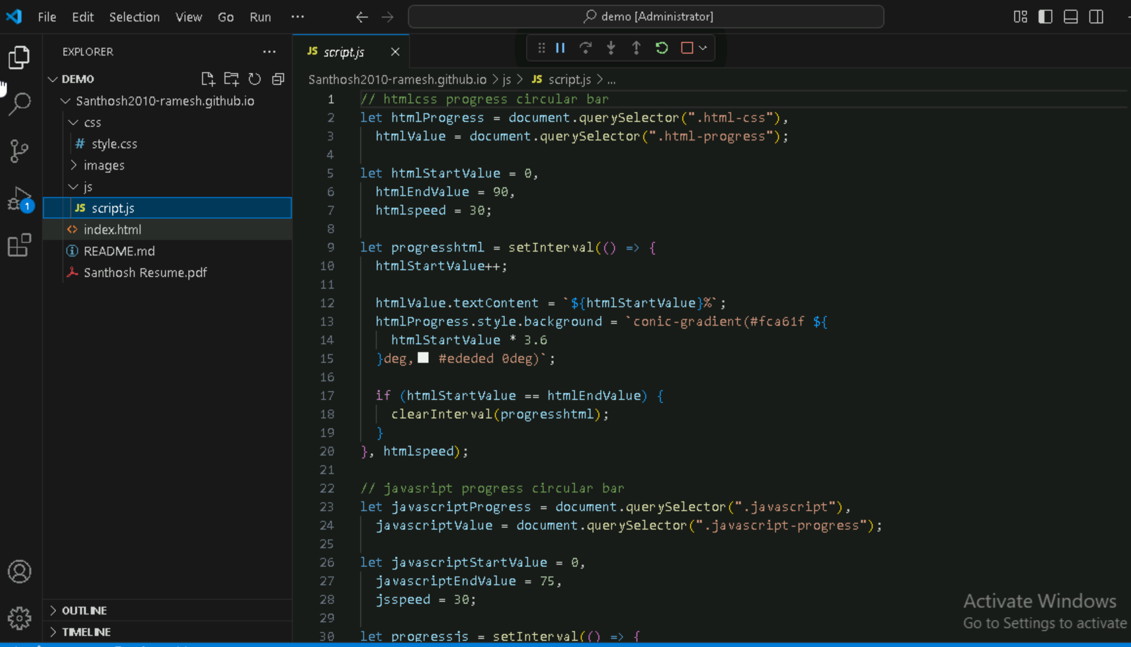

**Step 2:** Create a Github Repository

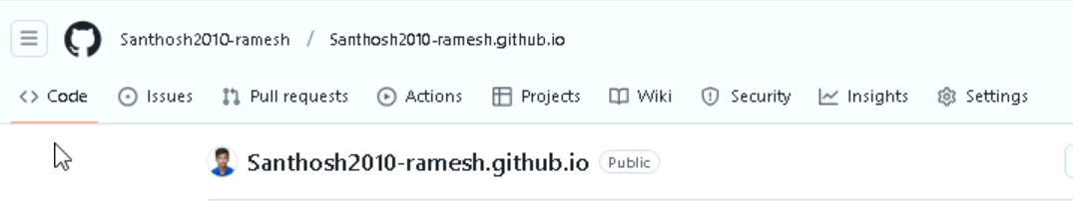

**Step 3:** Initiate a new git init command in local Machine

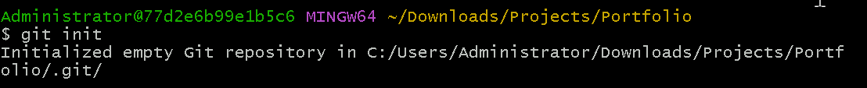

**Step 4:** Setup the remote URL



**Step 5:** Pull the files from Github **`git pull origin main`**



**Step 6:** Add all the files to staging area **`git add**



**Step 7:** Commit

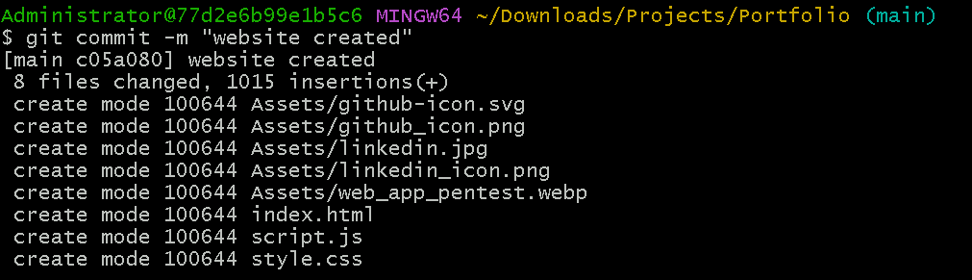

**Step 8:** Push the changes to github **`git push origin main**

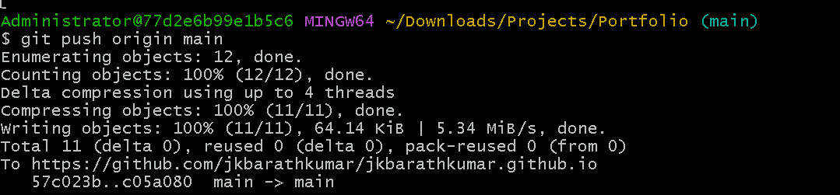

**Step 9:** Code pushed to github

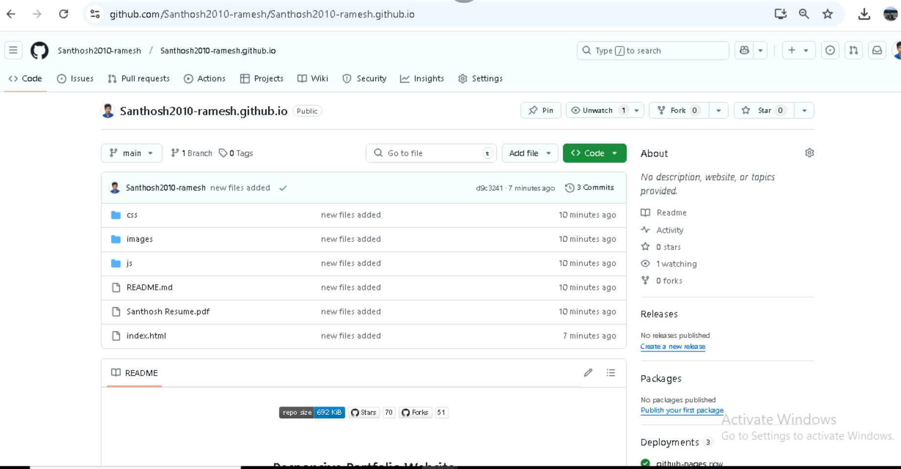

**Step 10:** Make changes in code

**Step 11:** Again added the changes, committed and pushed to github

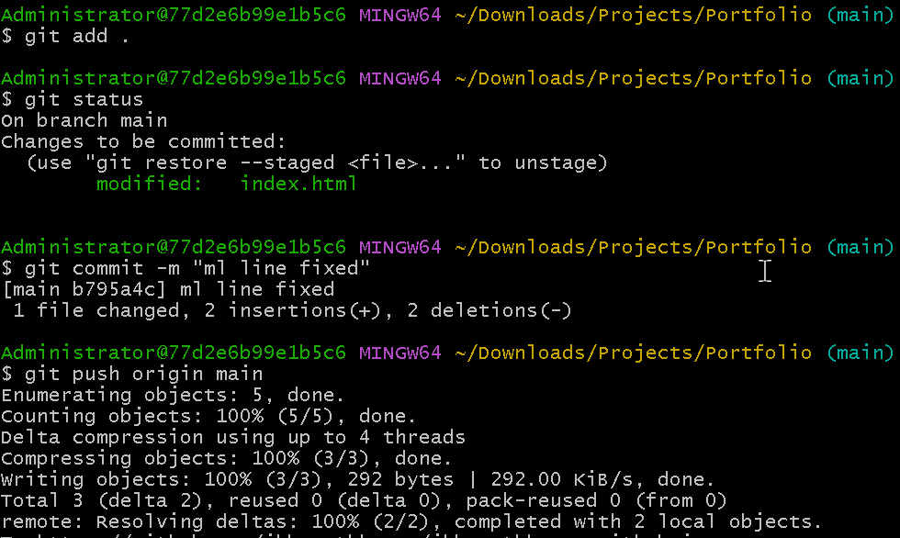

**Step 12:** Now the website pushed to github and hosted on github via git pages

